Appendix 5

Severe Weather Emergency

Procedures

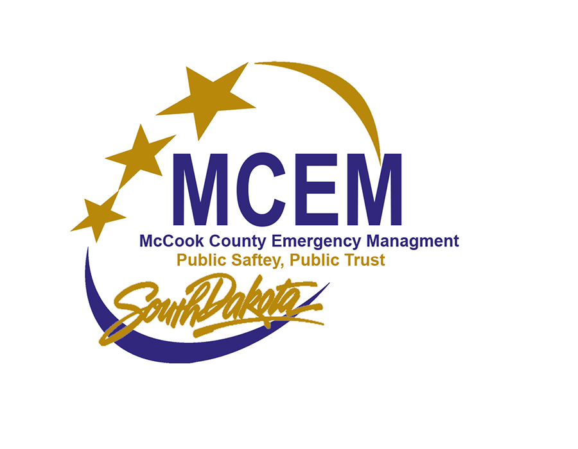

Severe Weather Emergency

Procedures

TABLE OF CONTENTS

- Outdoor Siren Purpose and Function
- Severe Weather Notifications
- Outdoor Siren Procedures
- Outdoor Siren Testing / Maintenance

Outdoor Siren Purpose and Function –

All McCook County Cities have installed outdoor warning siren systems to provide an additional warning of impending danger from threatening weather. As their name implies, our sirens are pre-incident warning devices manufactured and installed to be heard when people are out-of-doors or outside of their homes or other buildings. Although the outdoor warning sirens are often heard inside buildings, they are not designed or installed specifically to be heard inside buildings within their geographic coverage area.
You can be prepared for severe weather by listening to the forecast before leaving home. It is recommended that every home, school, and business be equipped with a NOAA All-Hazard Weather Radio. Detailed forecast information will be provided when severe weather watch and warning information is not being broadcast on the NOAA Weather Radio. You can also obtain local weather forecast information from commercial radio and television stations. Detailed forecasts can also be found online from several sites such as The National Weather Service.

If you are outside when the sirens sound, seek shelter immediately, turn on your TV or radio to a local broadcast, and/or listen to your NOAA All-Hazard Weather Radio to be informed of the emergency. DO NOT CALL 9-1-1 TO INQUIRE ABOUT THE SIRENS. Seek safe shelter inside a building, preferably in the basement or lowest level, away from glass, poorly anchored items, or insufficiently supported objects.
- Turn on local media and monitor your weather radio.
- If a tornado or life-threatening weather is imminent, immediately seek shelter in a sturdy, well-constructed building. A below-ground (basement) or certified storm shelter is best, but if this is not possible, move to the lowest level of the building and shelter in a small interior room (bathroom or closet) away from windows.
- If at home, follow your prepared emergency plan and keep your emergency kit within reach. See www.ready.gov for instructions for assembling an emergency kit.
- If at work or school, follow the established procedure and be attentive to changes in forecast information.

Severe Weather Notifications –

When severe weather strikes, it affects everyone. From city and town residents to local store owners, schools, and government agencies, it has the potential to disrupt everyday activities, destroy property, or even take lives. The following describes typical notifications in McCook County and the actions taken during those notifications.
Severe Weather Watches -
Weather watch
A weather watch is issued when dangerous weather conditions are likely to occur" to "A weather watch is issued when conditions are favorable for severe weather, but nothing has occurred.
Watch
- Conditions are favorable for severe weather, but it hasn't happened yet
- Be alert and ready to take action
- Get a plan in case a storm threatens
- Listen for later information and possible warnings
Actions—Emergency Management is notified through several outlets, including the Local Dispatch Center (PSAP), INWS, NOAA Weather Radio Stations, NWS Slac, Email, Text Message, and other local media sources. The situation is continuously monitored, and First Responders/Weather Spotters are placed in a heightened state or deployed depending on conditions.
Weather warnings
A weather warning is generally issued to more local areas. It alerts communities of severe weather, such as thunderstorms, flash floods, and tornadoes. People should not travel or venture outside when a weather warning is issued. Depending on the severity of the weather alert, they may also need to evacuate a given area. If people are traveling, they should head to shelter as soon as possible.

Warning
- Severe weather is occurring or about to occur
- Take action based on the emergency
- Weather conditions pose a threat to life or property
- People in the path of the storm need to take protective action
Actions—Emergency Management is notified through several outlets, including the Local Dispatch Center (PSAP), INWS, NOAA Weather Radio Stations, NWS Slac, Email, Text Message, and other local media sources. The situation is continuously monitored, and First Responders/Weather Spotters are deployed to monitor conditions. If the National Weather Service initiates a Tornado Warning for any portion of McCook County, Mitchell's Dispatch Center (PSAP) will automatically sound the county-wide Siren.

Outdoor Siren Procedures-

In addition to testing, there are 3 circumstances under which McCook County’s sirens will be activated.
- When the National Weather Service initiates a Tornado Warning for any portion of McCook County, the local 911 Center in Mitchell (PSAP) will send a county-wide tone that simultaneously sounds all Sirens in McCook County.
- When a public safety official or trained First responder/storm-spotter witnesses an active funnel cloud or tornado within McCook County, the Emergency Manager or 911 center is notified. The local 911 Center in Mitchell (PSAP) or the Emergency Manager will send a county-wide tone that sounds all Sirens in McCook County simultaneously or an individual Siren for that community, depending on Conditions and location at the time.
- Emergency Management receives credible reports of severe damage or a Direct and imminent threat to Life from hazardous weather, which can include conditions produced by thunderstorms, including damaging winds, tornadoes, large hail, etc..

Ability to Activate

- Emergency Management
- Local 911 Center Mitchell (PSAP)

Outdoor Siren Testing / Maintenance

Responsibilities / Maintenance –
Many years ago, the Weather Sirens were purchased with a Federal Grant to replace Aging Civil Defense Sirens. Once installed, these new sirens were transferred to the communities in which they resided and are the property and responsibility of each community. The communities are encouraged to maintain a Service agreement with a Siren Service entity to maintain and upkeep these sirens. McCook County is responsible for the Siren at Lake Vermillion and maintains a maintenance agreement for this Siren. All County Sirens also operate on a Battery backup system in case of power outages, which are common in severe weather. The Radio systems used to signal these sirens are also on Battery backup and automatically generator-backed Radio sites.

Testing -
Testing starts in April and goes to September every year. It is on the first Friday of every month at 10 a.m. This begins in April, when Most Area Weather Awareness efforts occur.

Failure / Success

The emergency Manager will contact each community and Lake Vermillion Staff to ensure the proper functioning or activation of Sirens during the testing Phase. If a Siren fails, the entity responsible for said Siren must take steps to repair/make serviceable their Siren. This is typically done through their service contracts yearly. However, if needed, the Emergency Manager can assist in finding the appropriate technicians in the area.

Testing Activations
These tests typically are cycled between being sounded by the PSAP and the Emergency manager via UHF Radio Two-Tone DTMF. The Sirens can also be set off locally at the Siren Box Itself, but few have access to these systems.

